Day 61: SR Latch Using NAND Gates

Introduction
An SR latch is a sequential circuit that stores one bit of data. It is constructed using two cross-coupled NAND gates.
Inputs:
- S̅ – Set input
- R̅ – Reset input
Outputs:
- Q – Normal output
- Q̅ – Complementary output

Truth Table
S̅ | R̅ | Q | Q̅ | Operation
0 | 0 | 1 | 1 | Invalid
0 | 1 | 1 | 0 | Set
1 | 0 | 0 | 1 | Reset
1 | 1 | Previous Q | Previous Q̅ | Hold

Working
- Set: When S̅ = 0 and R̅ = 1, Q = 1.
- Reset: When S̅ = 1 and R̅ = 0, Q = 0.
- Hold: When both inputs are 1, the latch retains its previous state.
- Invalid: When both inputs are 0, both outputs become 1.

Gate-Level Design

Design.

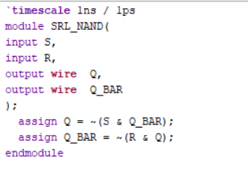

Waveform:

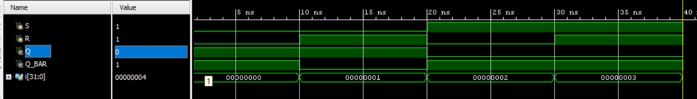

Schematic:

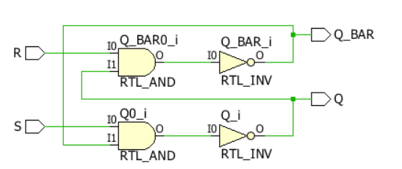

Behavioral-Level Design

Design.

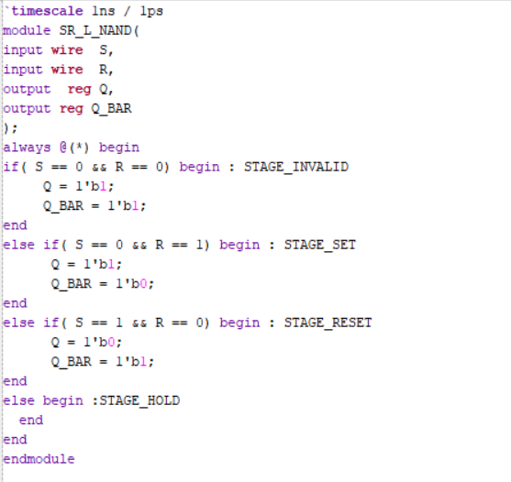

Waveform:

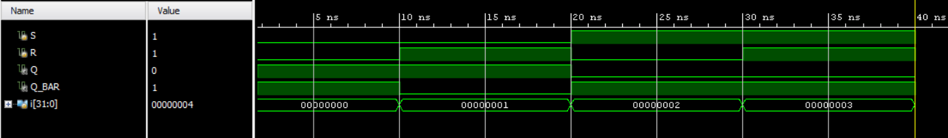

Schematic:

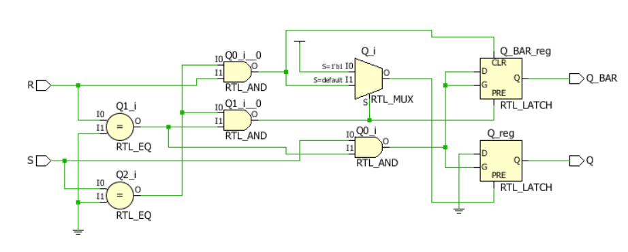

Testbench

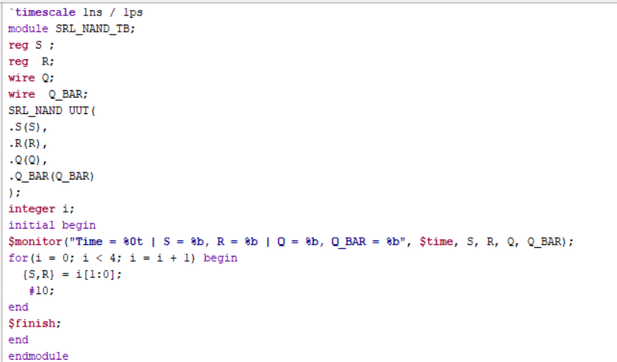

Observation:

Observation
- The SR latch is designed using two cross-coupled NAND gates.
- When S_N = 0 and R_N = 1, the latch performs the SET operation.
- When S_N = 1 and R_N = 0, the latch performs the RESET operation.
- When S_N = 1 and R_N = 1, the latch holds its previous state.
- When S_N = 0 and R_N = 0, the latch enters an invalid condition.

#PHANEENDRA.SINGUDASU

